Lora Chisholm

Web Dynamics (WWD 131)

Unit 1 Ponder: Running JavaScript

Scott Currell

Part 1.

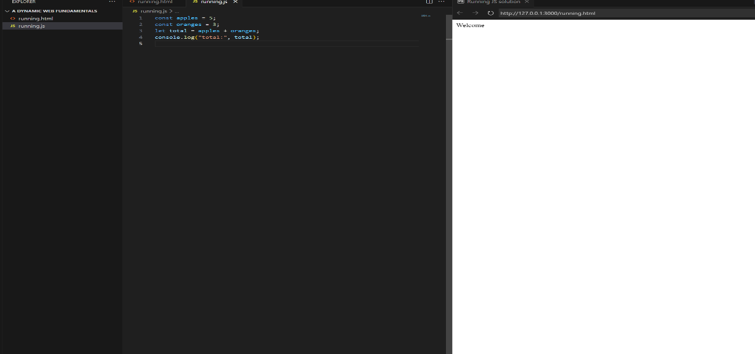

Running JS screenshot

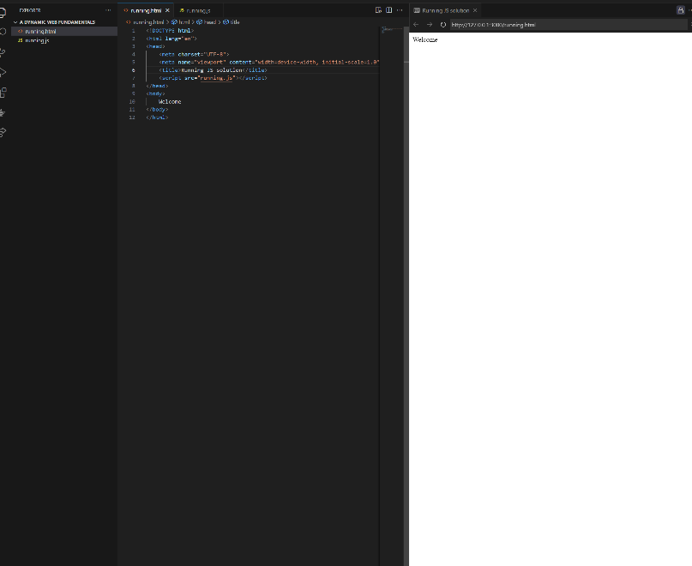

Running html screenshot

Activity 2 html page and output browser

Activity 2 javascript page

